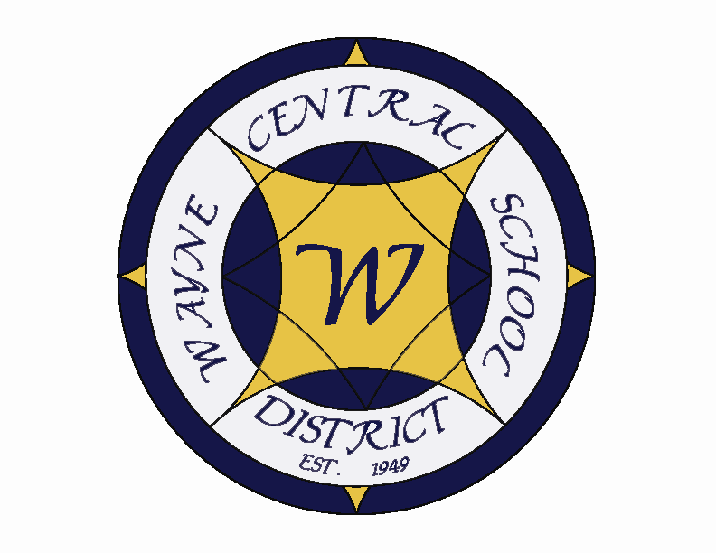
Letter to the Board

Michael Havens
Superintendent of Schools
Phone: 315-524-1001 Fax: 315-524-1049 mhavens@wayne.k12.ny.us

November 9, 2007

"The rules of cycling also apply to life. Take care of yourself. Set goals. Learn from the experts. Share your wisdom. Be prepared." --Karen Bliss Livingston, Olympic cyclist

Board Agenda:

- Executive Session: We will need to have an executive session at 6:00 to review a superintendent’s hearing appeal. The information from the student is attached as item B below. My written brief is attached at item A below.

- Building Tour: We will tour the middle school starting at 6:30 p.m. Mr. Armocida would like to begin the tour at the main office and end the meeting in the library for the start of the meeting.

- American Education Week: November 11-17 is American Education Week. We have commemorated the countless contributions of our staff with the attached letter along with the navy tablet portfolio which you received in your baskets last week. We are very fortunate to have wonderful people in every area of our district. American Education Week is just one opportunity we have to recognize their efforts. I will be reading the American Education Week Proclamation at the start of the Board meeting and have had it posted in every building to kick off the recognition.

- Facilities and Finance Presentation: Mr. Atseff has a powerpoint presentation that he will be presenting on our facilities and finance goals for the 07-08 school year. This plan was developed at the summer retreat.

- Teacher Resource Center: There will be a presentation on the new Teacher Resource Center. You will see its new middle school location as part of your 6:30 tour of the middle school facilities.

- Graduation Location: As you know, the Marvin Sands Constellation Foods Performing Arts Center at FLCC is no longer available to us for graduation ceremonies. The high school has booked the Rochester Convention Center. Mrs. Armitage will discuss the issue and the new date of Thursday, June 26.

- Financial Update: Mr. Atseff will present the financial update for October. Per your request, green and pink copies will be hand carried to the board meeting.

- Computerized Board Meetings: As we stated in August when we decided to convert to electronic board meetings, we stated we would revisit the decision to see how you felt about it. Time flies, it’s the second meeting in November and we should decide if we wish to continue the system, revise the process, or go back to the paper world.

- Student Representative: High School Sophomore Michelle Vendell will be the student representative at the November 15 board meeting. Michelle participated last year as well.

Board Letter:

1. Wayne County Administrators Meeting: We hosted the Wayne County Superintendents and Business Officials meeting here on Thursday. Each superintendent is volunteering to host a meeting. We were first. Unfortunately, the superintendent’s were so jealous of our facilities, including our T.V. studio that no one would go next. So our December meeting is back at BOCES.

2. NAC Musical “South Pacific”: The NAC musical South Pacific will be next weekend, Friday through Sunday, November 16-18 at 7:00 p.m. both Friday and Saturday evening, with a Sunday matinee at 2:00 p.m. Tickets can be purchased at locations around town and at school. They always put on a great show.

3. “Guitar Hero’s” Competition: Wayne High school is sponsoring a “guitar hero” show this Friday evening as a free event. Admission fee is a food pantry item which will go to fill our local food pantry. This event is sponsored by the high school key club.

4. Parent Complaint: You may be hearing a parent complaint because a middle school student tried out for, and made one or our junior varsity teams. This has been done every year for a long time through the state. We follow the rules of the New York State High School Athletic Association to which we belong. It is common to see middle school wrestlers, volleyball players and soccer players advancing to the high school level, just as we have high achieving middle school students taking high school courses. The difficulty for this parent, as I am sure you can understand, is that his daughter did not make the team.

5. Social Studies Testing: The Grade 5 Social Studies Assessment Testing will be on November 14 & 15. This is the earliest of the assessment tests and one that our children have routinely done well on.

6. Veteran’s Day Holiday: Just a reminder, the school will be closed Monday to honor the Veteran’s Day holiday.

7. Upcoming Events:

11/13 – National Honor Society Induction Ceremony – PAC – 7:00 p.m.
11/15 – Board of Education Meeting @ Middle School – 6:30 p.m.
11/16–18 – NAC Musical “South Pacific”
11/20 – Policy Committee Meeting @ District Office – 4:30 p.m.
11/21-25 – Schools Closed – Thanksgiving Recess
11/27 – OP/OE PTA Meeting @ OP Cafeteria
11/29 – Parent Teacher Conferences
11/30 – HS Drama Club One Act Plays @ PAC – 7:00 p.m.

8. Attachments

A) Hearing Appeal Written Brief (Lindloff) – Superintendent’s
B) Hearing Appeal Letter - Lindloff
C) Four County News & Notes
D) Policy Committee Meeting Minutes - 11/6
E) Safety Committee Meeting Minutes – 10/30

Att. A)

Wayne Central School District

Office of the Superintendent of Schools

Memorandum

TO: Board of Education

FROM: Michael Havens
RE: Appeal of Trey Lindloff
DATE: November 9, 2007

Attached is the parental appeal of my decision of November 1, 2007 in which I found Trey Lindloff guilty of being under the influence of Marijuana.

For many of you, this will be your first appeal. They do not happen often. The appeal is not a retrying of the case but occurs through your review of a written request. This letter will outline the district’s position. You will be discussing the appeal in executive session on Thursday. In order to accommodate this we will need to begin our meeting at 6:00 with a 6:30 tour of the building.

After discussion in executive session, you’ll have to render a decision through an actual vote in the regular session of the meeting. You can vote to do one of four things;
- support the superintendent’s decision
- overturn the superintendent’s decision
- modify the superintendent’s decision
- have the superintendent rehear the case

The high school presented the following facts for my consideration at the hearing;

- On October 24th, prior to 7:30, a teacher reported detecting the odor of Marijuana on Trey.
- At 7:55 a second teacher reported smelling marijuana on Trey.
- Upon questioning by the assistant principals, Trey said he rode to school with another student and they were smoking a cigar. At that time both assistants smelled marijuana on Trey.
- The second student was questioned and also smelled of marijuana.
- That student gave permission for a search of his car.
- That search yielded a substance which proved to be marijuana when field tested by the SRO.
- The car reeked of the smell of marijuana.

In defending himself Trey, maintained he was not guilty. He explained his smelling like marijuana by saying he had smoked a cigar on the way to school. When Mrs. Armitage and Mr. Derse testified that it did not smell like a cigar but like marijuana he suggested that it might be because he smoked marijuana the night before. After acknowledging to me that he took a shower that morning and that he was wearing different clothes than the previous night, he could not explain why he still smelled like marijuana except that he smoked a cigar. There also was no credible explanation as to how the marijuana got in the car.

I considered the case and decided that the preponderance of evidence showed that he was guilty. As you can see from my letter to Mrs. Fioco dated November 1st he received a lighter than normal suspension for smoking marijuana. I allowed him to reduce that suspension even further if he maintained good grades and attended counseling with our new drug and alcohol counselor.

I am confident about this decision. I believe that Mrs. Fioco inadvertently admits that even she believes he was guilty when she says “He has been punished at home”. I don’t believe mom would punish him unless she also felt he was culpable.

Thank you for your consideration.
Att. B)
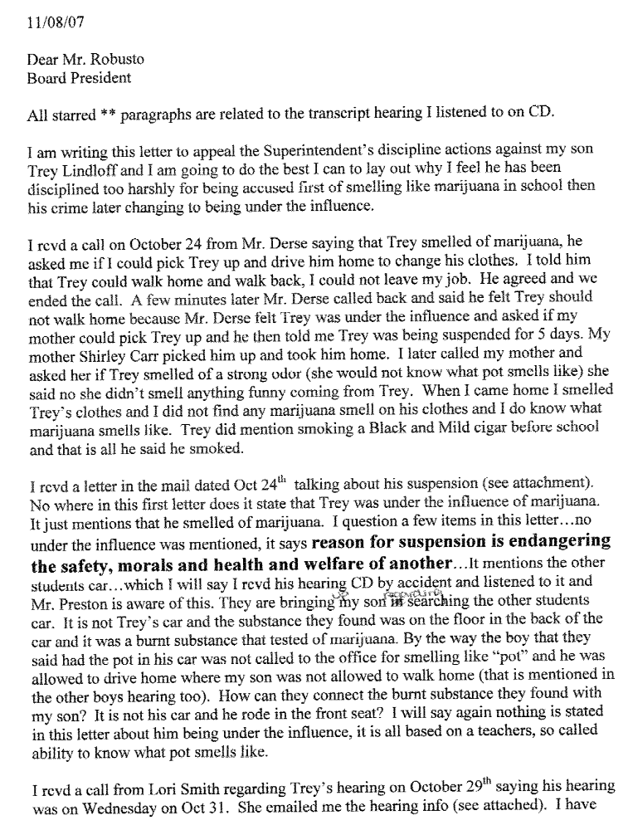
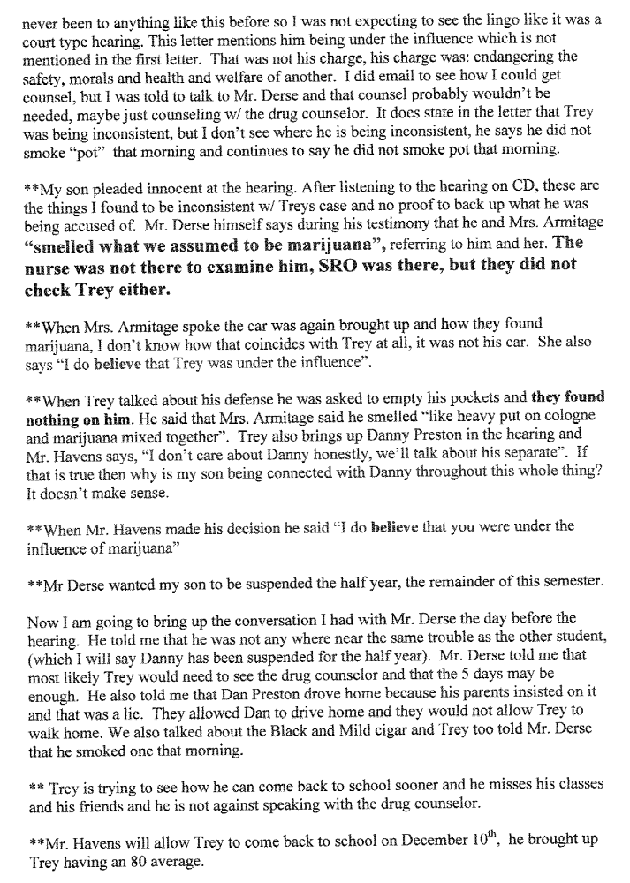
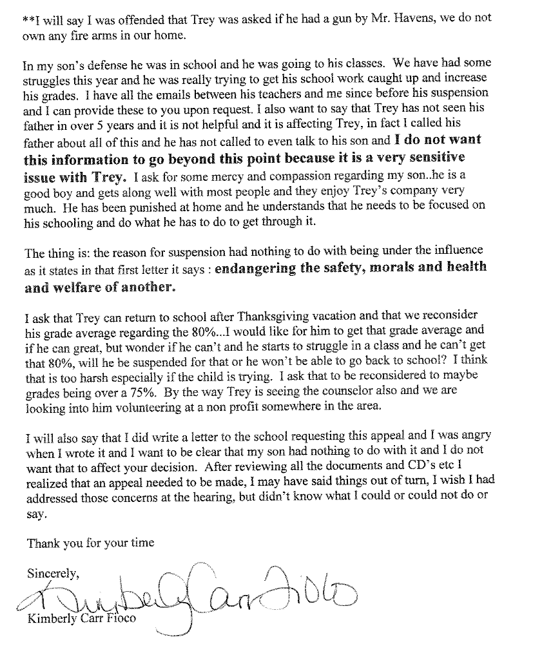
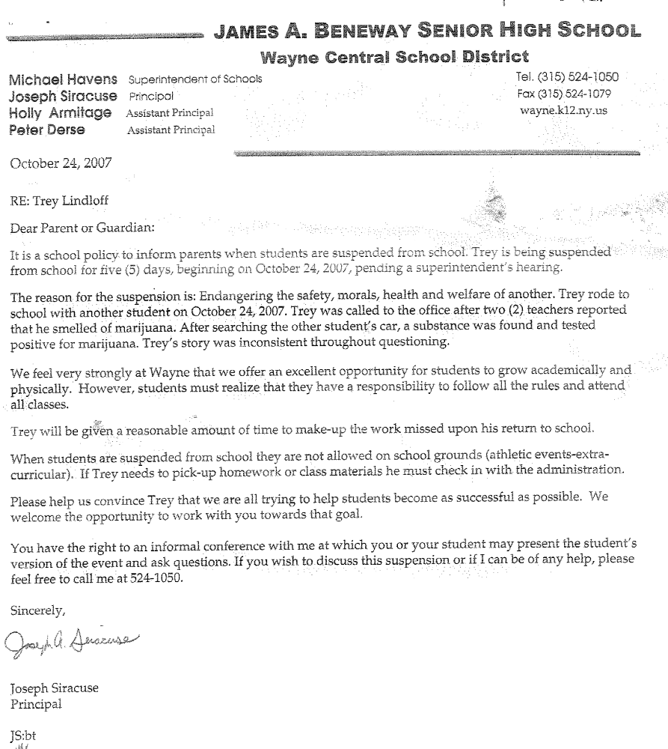
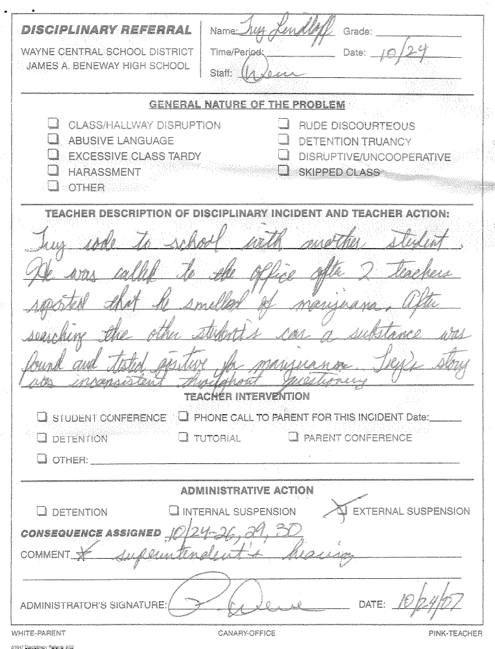
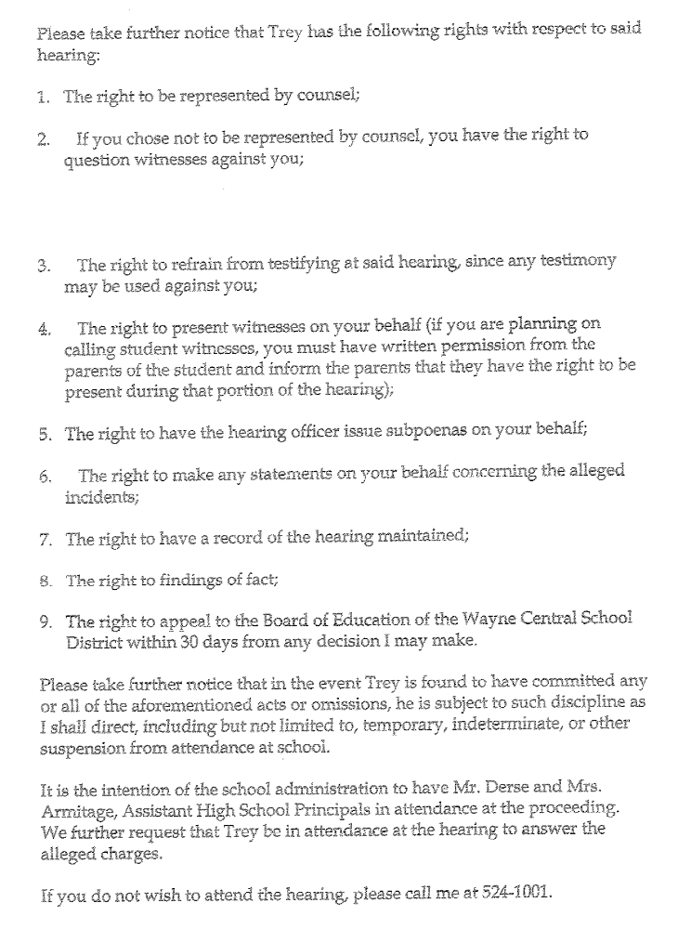
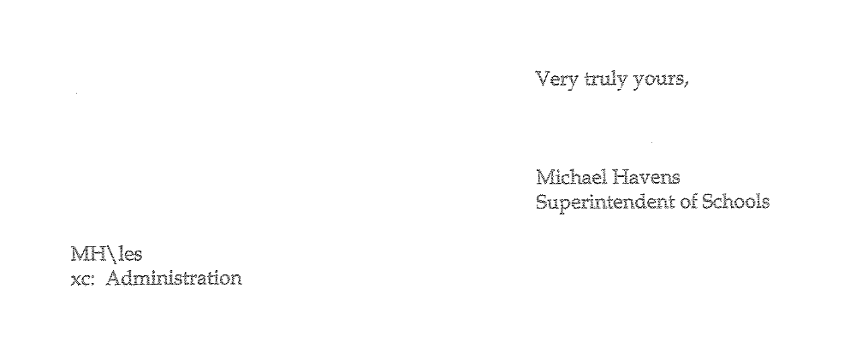
Att. C)
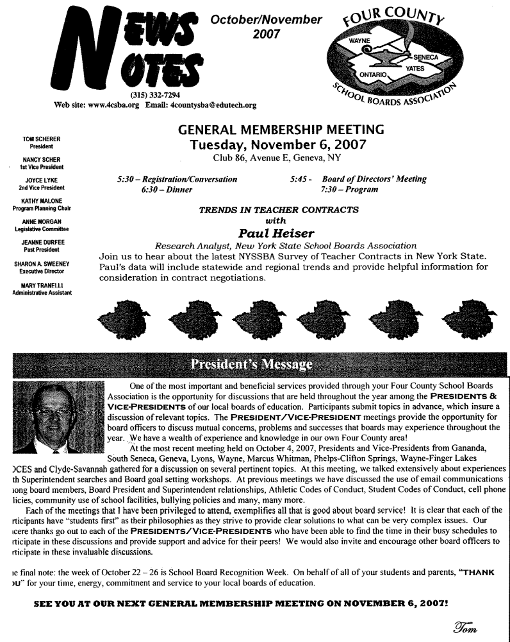
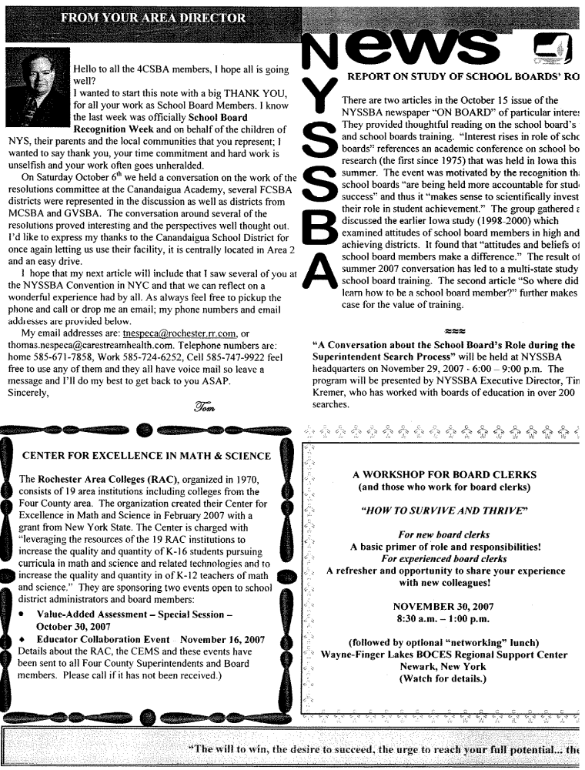
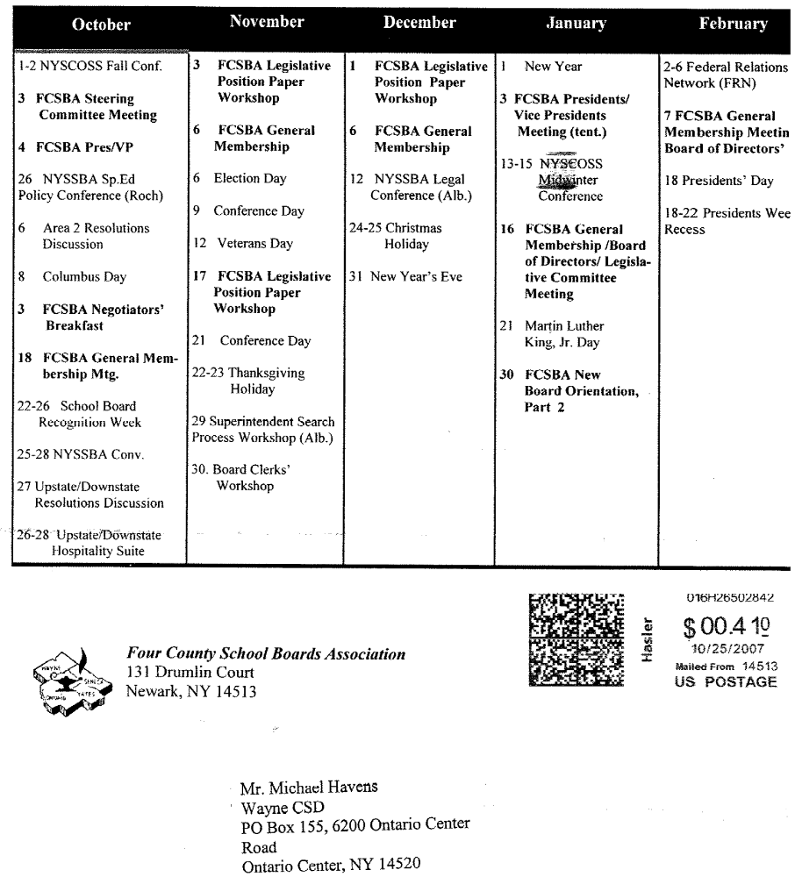
Att. D)

POLICY COMMITTEE MINUTES
DATE: Tuesday, November 6, 2007 TIME: 4:30 p.m. PLACE: District Office

COMMITTEE MEMBERS: Mrs. Newman, Mr. Triou, Mr. Atseff, Mr. Switzer

PRIOR MEETING MINUTES: Minutes of the meeting of October 16, 2007 were filed as presented.

OLD BUSINESS:

- Proposed Committee Charge – 2007-2008: Mrs. Newman noted that the proposed committee charge for 2007-2008 was approved by the Board of Education on November 1, 2007.

- Draft Revisions – Policy 5321/Regulation 5321 – Reimbursement for Travel & Conference: Committee members reviewed the proposed revisions and agreed to changes. The committee approved presentation of these proposed revisions, as amended, to the Board of Education for first reading (policy) and single reading (regulation) on November 15th.

- Draft Revisions – Section 1000 – Annual Review – Revisions and Amendments: Committee members reviewed the proposed revisions to varied policies in this section and agreed to changes. The committee approved presentation of these proposed revisions, as amended, to the Board of Education for first reading on November 15th.

NEW BUSINESS:

- Annual Review – 50% of Existing Policy Handbook – 2007-2008: Mrs. Newman stated that review of proposed revisions to Section 2000 (internal operations) & Section 3000 (community relations) will occur at the next committee meeting.

NEXT MEETING: November 27, 2007 (tentative) @ 4:30 p.m. @ District Office

ADJOURNMENT: 5:20 p.m.

NEXT & FUTURE MEETING AGENDA ITEMS:
• Follow-Up On: First Reading – Policy Revisions – Section 1000
• Follow-Up On: First Reading – Policy Revision – 5321 – Reimbursement for Travel & Conference
• Follow-Up On: Single Reading – Regulation Revision – 5321R – Reimbursement for Travel & Conference
• Proposed Revisions: Section 2000 - Policy & Regulations
• Proposed Revisions: Section 3000 – Policy & Regulations

JES/jes:wp
Att. E)
TO: Safety Committee Members:
Chris Shaffer - Committee Co-Chairperson (MS Asst. Principal)
Fred Prince - Transportation
Maureen Doyle – MS PE
Tom Lucieer – OE Maintenance
Mark Callahan - DO Administration
Lori Sensenbach – OP SCRIP
Pamela Buddendeck– FE Instructional
Rob Chapman – SRO
Mark Wyse - School Board Rep.
Pat Griswold – OE Nurse
Anna McGrath– HS Science

FROM: Bob Miller – Committee Co-Chairperson (Dir. of Facilities)
RE: Meeting Minutes
DATE: October 30, 2007

The committee welcomed Rob Chapman to the district as our new SRO.

Old Business

I looked into the issue of the 45 mph speed limit in front of Freewill Elementary. The district has sent a letter to the Walworth town board requesting the speed limit be reduced to 30 mph. I sent a letter to the resident who originally brought this issue up to keep them informed.

I called Simplex and had them install a fire alarm chime and strobe in the Tot Spot child care center. Tot Spot can now hear fire drill signals when all of their doors are closed. Stacy, Tot Spot director, thanked the district for the quick response.

The Homeland Security Booklet is being updated to include procedures for Freewill Elementary during a lockdown. There was also a request to have more of the booklets sent to each building.

New Business

I received a letter from the Department of Health regarding art clay that is used for ceramics. Some of the dry clay had talc in it that may contain asbestos. I contacted the building art departments and all currently use the moist clay. The middle school had some old, dry clay which was disposed of.

I found a cabinet in the middle school basement that had old science chemicals in it. I called Riley Wheaton, chemical hygiene officer for the district, who will have it properly disposed of.

There has been a lot of communication regarding MRSA (super bug) between nurses and myself. As a preventative measure I have the cleaning staff disinfecting counter tops, desk tops, door knobs, etc. We all agreed that personal hygiene is key to not contracting this staph infection.

We are currently working on card access procedures for after school and weekend use of all buildings without compromising security.

Our next meeting will be on Thursday November 29th at 8:00. Hope to see you there…

